WEBGL PROGRAMMING LAB

Submitted By
Naman Jain
R142215024
500046336

under the guidance of
MR. BHUPENDRA SINGH
Assistant Professor, SoCSE



Department of Virtualization
School of Computer Science and Engineering
Bidholi, Via Prem Nagar, Dehradun
Uttarakhand-248007

Experiment No. 1
DATA PAGE
<html>
<head>
<title>Info Page</title>
</head>
<link rel="stylesheet" href="https://www.w3schools.com/w3css/4/w3.css">
<body bgcolor="powderblue" style="color:darkblue;" style="font-family:courier">
<hr>
<div class="w3-panel w3-leftbar w3-border-blue w3-pale-blue">
<h1 style="color:darkblue"><center><b>NAMAN JAIN</b></center></h1>
</div>
<hr>
<br>
<br>

<img src="Photo.jpg" align="left">
<center><p>
<h3>I am pursuing my B.Tech from University of Petroleum and Energy Studies,Dehradun.I love to design games and that's why i am enrolled in the Graphics and Gaming specialization.</h3>
</p></center>
<br>
<div class="w3-panel w3-leftbar w3-border-blue w3-pale-blue">
<p><h3 style="color:darkblue">My Interests!</h3></p>
</div>
<ul>
<li>Designing
<li>Gaming
<li>Editing
</ul>
<div class="w3-panel w3-leftbar w3-border-blue w3-pale-blue">
<p><h3 style="color:darkblue">My Technical Skills!</h3></p>
</div>
<ul>
<li>C/C++
<li>Java
<li>pHp
<li>Adobe Photoshop
</ul>
<div class="w3-panel w3-leftbar w3-border-blue w3-pale-blue">
<h3 style="color:darkblue">Favourite Subjects</h3>
</div>
<ul>
<li>Computer Graphics
<li>Maths
<li>WebGl
</ul>
<div class="w3-panel w3-leftbar w3-border-blue w3-pale-blue">
<h3 style="color:darkblue">Academics:</h3>
</div>
<table style="width:100%" border="2px">
<tr>
<th>Year</th>
<th>Class</th>
<th>Marks</th>
</tr>
<tr>
<td>2013</td>
<td>Xth</td>
<td>10 CGPA</td>
</tr>

<tr>
<td>2015</td>
<td>XIIth</td>
<td>95%</td>
</tr>

<tr>
<td>2016</td>
<td>Ist year</td>
<td>8 CGPA</td>
</tr>

<tr>
<td>2017</td>
<td>IInd Year</td>
<td>8.5 CGPA</td>
</tr>
</table>
<br>
<div class="w3-panel w3-leftbar w3-border-blue w3-pale-blue">
<center><h3 style="color:darkblue">Contact Details:</h3></center>
</div>
<h4>7838414038</h4>
<h4>naman.jain.may@gmail.com</h4>
<hr>
</body>
</html>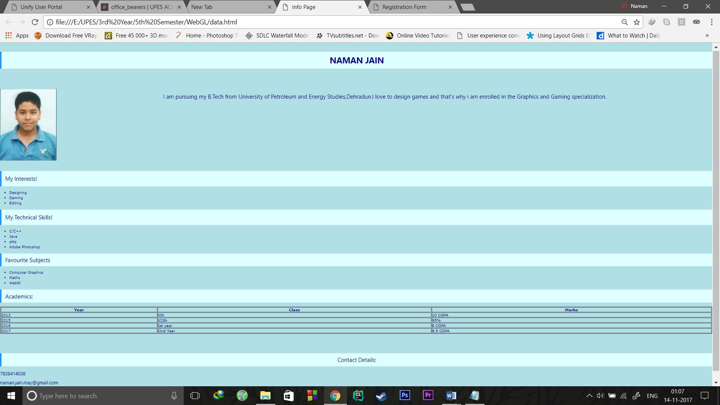


EXPERIMENT 2
SVG SHAPES
<!DOCTYPE html>
<html>
<body>

<svg width="1000" height="1000">
<rect width="1000" height="1000" style="fill:rgb(0,0,255);stroke-width:3;stroke:rgb(0,0,0)" />
<circle cx="50" cy="50" r="40" stroke="black" stroke-width="3" fill="yellow" />
<circle cx="950" cy="50" r="40" stroke="black" stroke-width="3" fill="yellow" />
<circle cx="950" cy="950" r="40" stroke="black" stroke-width="3" fill="yellow" />
<circle cx="50" cy="950" r="40" stroke="black" stroke-width="3" fill="yellow" />

<rect x="500" y="500" rx="20" ry="20" width="400" height="350"
style="fill:red;stroke:black;stroke-width:5;opacity:0.5" />
<rect x="200" y="200" rx="20" ry="20" width="400" height="350"
style="fill:green;stroke:black;stroke-width:5;opacity:0.5" />
Sorry, your browser does not support inline SVG.
</svg>

</body>
</html>
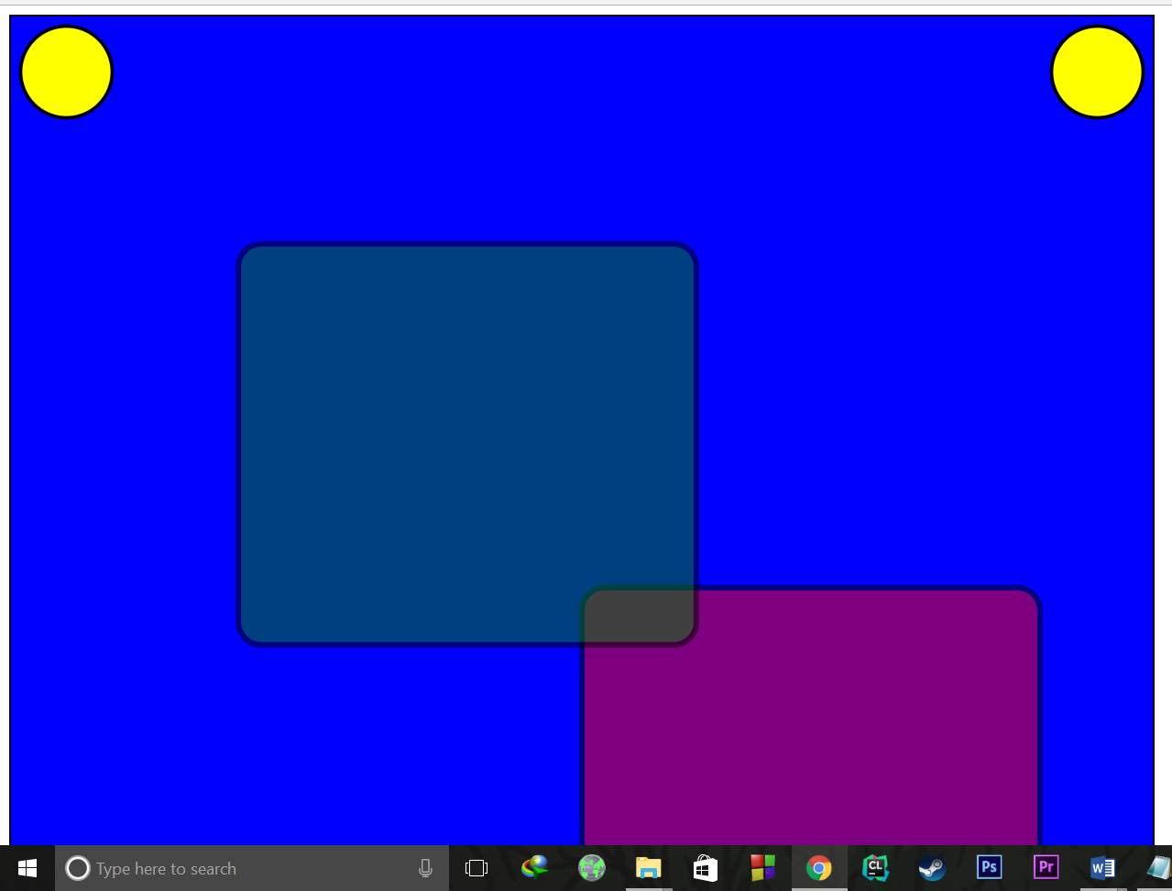

SIMPLE SMILEY
<!DOCTYPE html>
<html>
<body>
<canvas id="myCanvas" width="1500" height="700" style="border:1px solid #d3d3d3;">
Your browser does not support the HTML5 canvas tag.</canvas>
<script>
var c = document.getElementById("myCanvas");
var ctx = c.getContext("2d");
ctx.arc(500,300,250,0,2*Math.PI,true);
ctx.moveTo(420,200);
ctx.arc(400,200,20,0,2*Math.PI,true);
ctx.moveTo(620,200);
ctx.arc(600,200,20,0,2*Math.PI,true);
ctx.moveTo(600,400);
ctx.arc(500,400,100,0,2*Math.PI,true);

ctx.stroke();

</script>

</body>
</html>
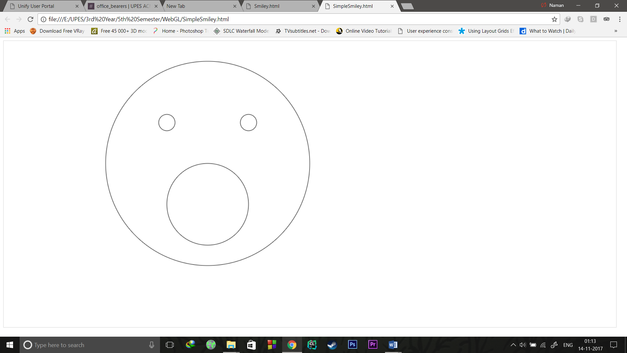

RANDOM SMILEY

<!DOCTYPE html>
<html>
<body onload="animate()">
<canvas id="myCanvas" width="1500" height="700" style="border:1px solid #d3d3d3;">
Your browser does not support the HTML5 canvas tag.</canvas>
<input type="range" min="100" max="1000" step="10" onChange="updtime(this.value)">
<script>
var t=300;
function animate()
{setInterval(initfunc,t);}
function updtime(z)
{t=1000-z;
animate();}
function initfunc()
{var speed;
var c = document.getElementById("myCanvas");
var ctx = c.getContext("2d");
var wid=Math.random()*1500;
var hei=Math.random()*700;
ctx.clearRect(0,0,1500,700);
ctx.beginPath();
ctx.fillStyle="#FFFF00";
ctx.lineWidth="3";
ctx.arc(parseInt(wid),parseInt(hei),100,0,2*Math.PI,true);
ctx.fill();
ctx.moveTo(parseInt(wid)-40,parseInt(hei)-50);
//ctx.fillStyle="#FFFFFF";
ctx.arc(parseInt(wid)-50,parseInt(hei)-50,10,0,2*Math.PI,true);
ctx.fill();
ctx.moveTo(parseInt(wid)+60,parseInt(hei)-50);
//ctx.fillStyle="#FFFFFF";
ctx.arc(parseInt(wid)+50,parseInt(hei)-50,10,0,2*Math.PI,true);
ctx.fill();
ctx.moveTo(parseInt(wid)+30,parseInt(hei)+50);
//ctx.fillStyle="#FFFFFF";
ctx.arc(parseInt(wid),parseInt(hei)+50,30,0,2*Math.PI,true);
ctx.fill();
ctx.stroke();
}
</script>
</body>
</html>

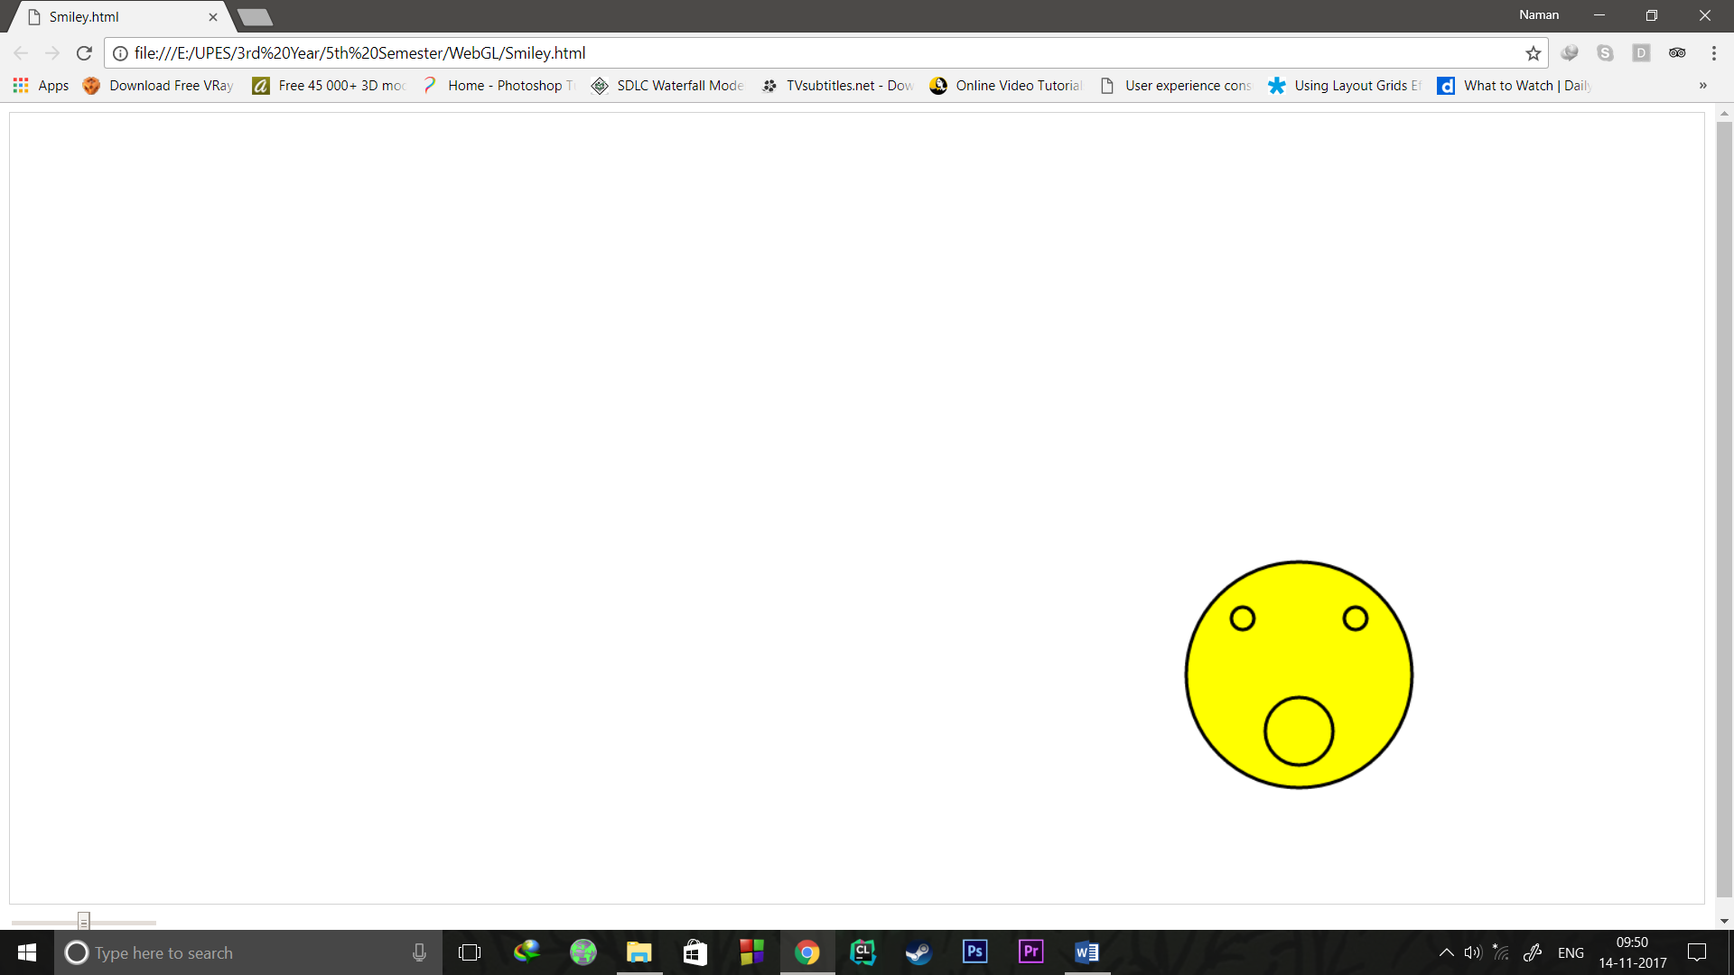
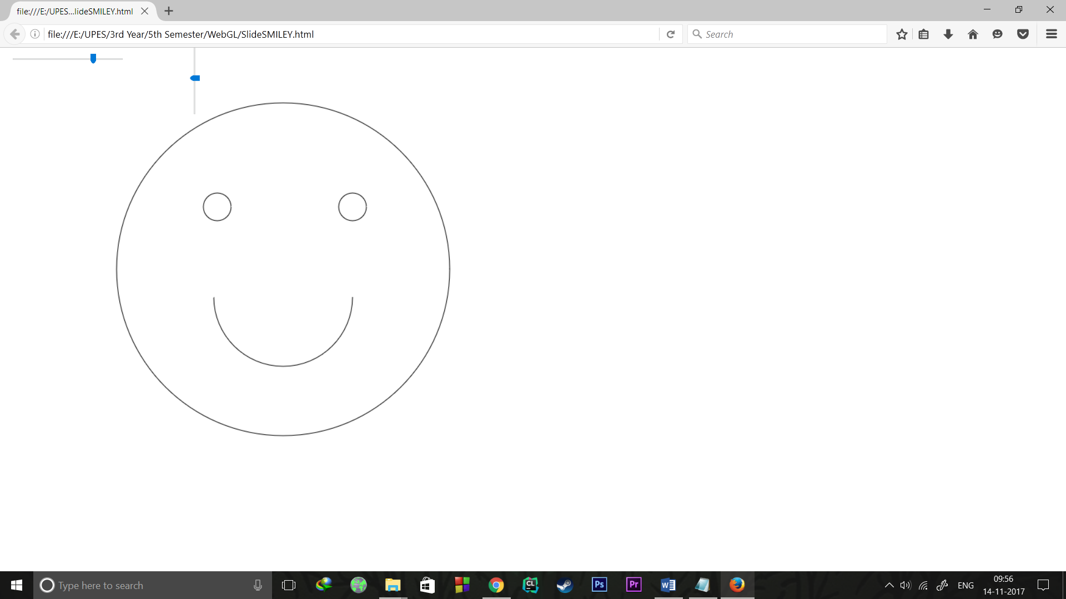

TRUCK ANIMATION

<!DOCTYPE html>
<html>
<body onload="animate()">

<canvas id="myCanvas" width="1500" height="700" style="border:1px solid #d3d3d3;">
Your browser does not support the HTML5 canvas tag.</canvas>
<script>
var x=10;
function animate(){
setInterval(draw,5);
}
function draw(){
if(x>1600)
x=0;
else
x=x+1;
var c = document.getElementById("myCanvas");
var ctx = c.getContext("2d");
var my_gradient=ctx.createLinearGradient(0,0,170,0);
my_gradient.addColorStop(0,"green");
my_gradient.addColorStop(1,"blue");
ctx.clearRect(0,0,c.width,c.height);
ctx.beginPath();
ctx.rect(20+x,200,600,250);
ctx.moveTo(x+110,490);
ctx.fillStyle="#FF0CFF";
ctx.fillRect(x,180,640,290);
ctx.fillStyle="#00FFFF";
ctx.fillRect(640+x,320,200,150);
ctx.fillStyle="#FFFF00";
ctx.fillStyle=my_gradient;
ctx.fillRect(740+x,320,100,75);
ctx.arc(100+x,490,10,0,2*Math.PI,true);
ctx.moveTo(550+x,490);
ctx.arc(540+x,490,10,0,2*Math.PI,true);
ctx.moveTo(555+x,490);
ctx.arc(540+x,490,15,0,1*Math.PI,true);
ctx.moveTo(115+x,490);
ctx.arc(100+x,490,15,0,1*Math.PI,true);
ctx.stroke();
}
</script>
</body>
</html>
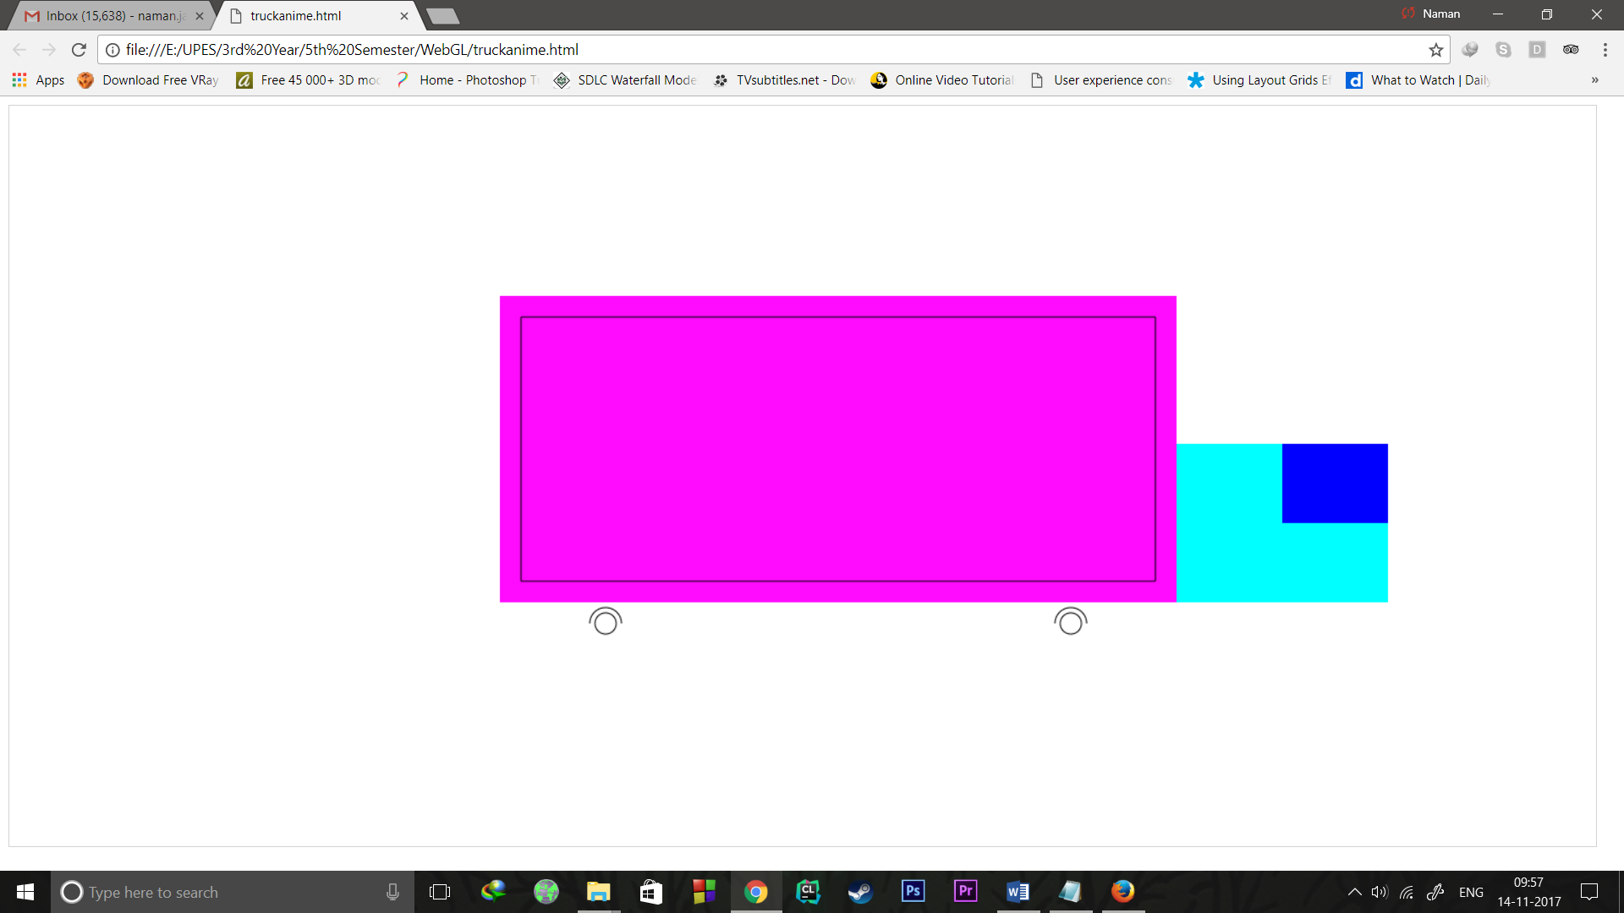
SIMPLE TRUCK
<!DOCTYPE html>
<html>
<body>

<canvas id="myCanvas" width="1500" height="700" style="border:1px solid #d3d3d3;">
Your browser does not support the HTML5 canvas tag.</canvas>

<script>

var c = document.getElementById("myCanvas");
var ctx = c.getContext("2d");
var my_gradient=ctx.createLinearGradient(0,0,170,0);
my_gradient.addColorStop(0,"green");
my_gradient.addColorStop(1,"blue");
ctx.beginPath();
ctx.rect(300,200,600,250);
ctx.moveTo(390,490);
ctx.fillStyle="#FF00FF";
ctx.fillRect(280,180,640,290);
ctx.fillStyle="#00FFFF";
ctx.fillRect(920,320,200,150);
ctx.fillStyle="#FFFF00";
ctx.fillStyle=my_gradient;
ctx.fillRect(1020,320,100,75);
ctx.arc(380,490,10,0,2*Math.PI,true);
ctx.moveTo(830,490);
ctx.arc(820,490,10,0,2*Math.PI,true);
ctx.moveTo(835,490);
ctx.arc(820,490,15,0,1*Math.PI,true);
ctx.moveTo(395,490);
ctx.arc(380,490,15,0,1*Math.PI,true);
ctx.stroke();

</script>

</body>
</html>
ZOOMING CIRCLE
<!DOCTYPE html>
<html>
<body onload="animate()">

<canvas id="myCanvas" width="1500" height="700" style="border:1px solid #d3d3d3;">
Your browser does not support the HTML5 canvas tag.</canvas>

<script>
var t=300;
var rad=10;
function animate()
{
setInterval(initfunc,t);
}

function initfunc()
{
var speed;
if(rad>290)
rad=10;
else
rad=rad+10;
var c = document.getElementById("myCanvas");
var ctx = c.getContext("2d");
//ctx.clearRect(0,0,1500,700);
ctx.beginPath();
ctx.arc(700,300,parseInt(rad),0,2*Math.PI,true);
ctx.stroke();

}
</script>
</body>
</html>
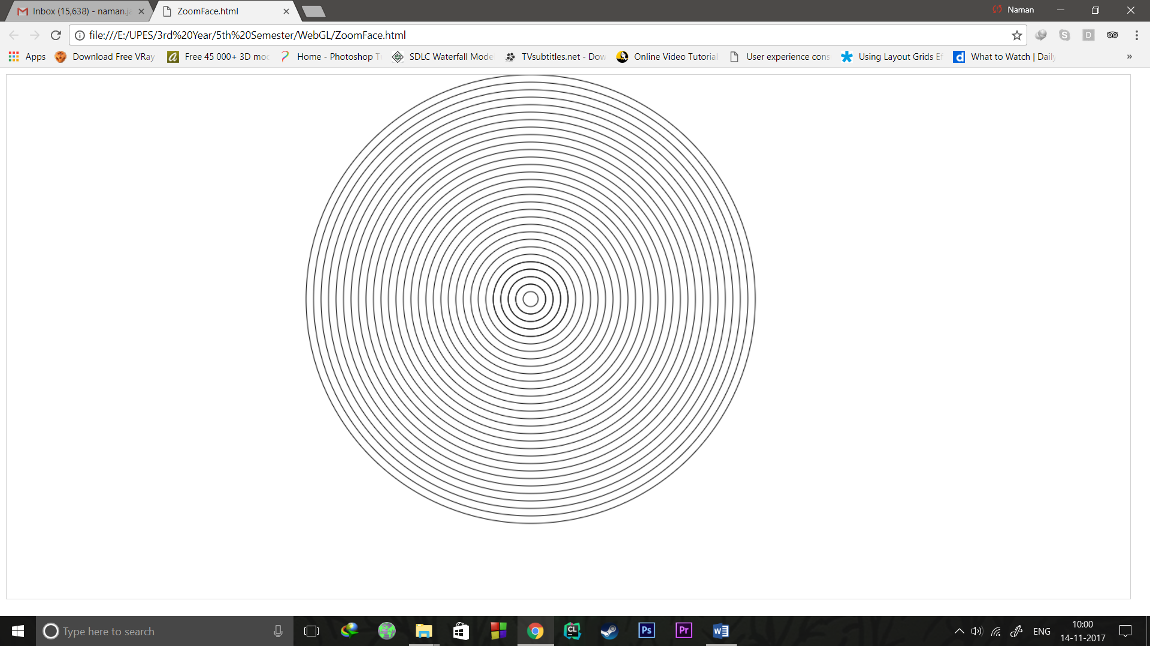

IMAGE COLLISION
<html>
<head>
<title>CAR
</title>
</head>
<body onload="animate()">
<canvas id="myCanvas" width="1500" height="700" style="border:1px solid #d3d3d3;">
<script>
var canvas =document.getElementById("myCanvas");
var cdx=canvas.getContext("2d");
var img=new Image();
var img2=new Image();
var x=0;
var y;
var score=0;
function animate(){
setInterval(init,200);
}

function init(){

y=Math.random()*700;
cdx.clearRect(0,0,1500,700);
cdx.font="30px Arial";
cdx.fillText(score,1400,100);
cdx.rect(1200,200,100,100);
cdx.stroke();
img.src="download.png";
img2.src="human.png";

img.onload=function(){
if(x>=1300)
x=0;
else
x=x+50;
cdx.drawImage(img,x,200);
}

img2.onload=function(){
cdx.drawImage(img2,1200,y);
}

if((x>=1150)&&(x<=1250)&&(y>150)&&(y<250))
score=score+1;

}
</script>
</body>
</html>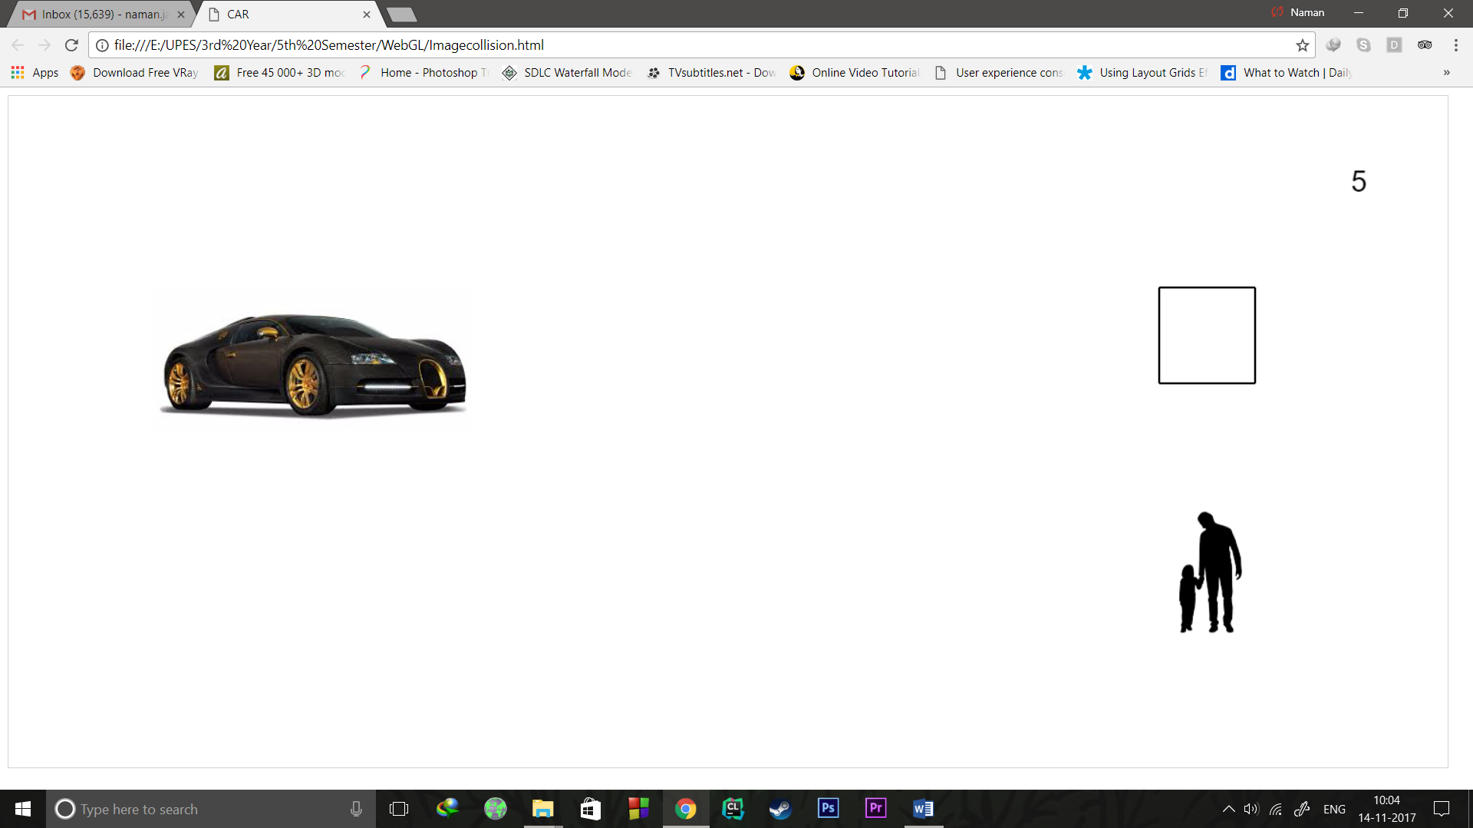

BEZIER CURVE LANDSCAPE
<!DOCTYPE html>
<html>
<body>

<canvas id="myCanvas" width="1500" height="700" style="border:1px solid #d3d3d3;">
Your browser does not support the HTML5 canvas tag.</canvas>

<script>
var c = document.getElementById("myCanvas");
var ctx = c.getContext("2d");
ctx.fillStyle="#0000ff";
ctx.beginPath();
ctx.moveTo(0,0);
ctx.rect(0,0,1500,700);
ctx.stroke;
ctx.fill();

ctx.fillStyle="#ffffff";
var i=0;
while(i<34){
var x=Math.random()*1450;
var y=Math.random()*600;
ctx.beginPath();
ctx.moveTo(x,y);
ctx.arc(x,y,3,0,2*Math.PI,true);
ctx.stroke();
ctx.fill();
i++;
}

ctx.fillStyle="#ffff00";
ctx.beginPath();
ctx.moveTo(300,700);
ctx.bezierCurveTo(300,700,600,10,900,700);
ctx.stroke;
ctx.fill();
ctx.fillStyle="#00ff00";
ctx.beginPath();
ctx.moveTo(100,700);
ctx.bezierCurveTo(100,700,300,200,500,500);
ctx.bezierCurveTo(500,500,700,700,900,500);
ctx.bezierCurveTo(900,500,1100,200,1300,700);
ctx.stroke();
ctx.fill();
var x=-100;
ctx.fillStyle="rgb(0,153,0)";
ctx.beginPath();
ctx.moveTo(100+x,700);
ctx.bezierCurveTo(100+x,700,300+x,200,500+x,500);
ctx.bezierCurveTo(500+x,500,700+x,700,900+x,500);
ctx.bezierCurveTo(900+x,500,1100+x,200,1300+x,700);
ctx.stroke();
ctx.fill();

</script>

</body>
</html>